**Relational Database Design**

**Problem Statement:**

How to convert a relational design into tables in SQL Server Topics: In this project, you will work on converting a relational design that enlists various users, their roles, user accounts, and their statuses into different tables in SQL Server and insert data into them. Having at least two rows in each of the tables, you have to ensure that you have created respective foreign keys.

**Tasks to Be Performed:**

* Define relations/attributes.
* Define primary keys
* Create foreign keys

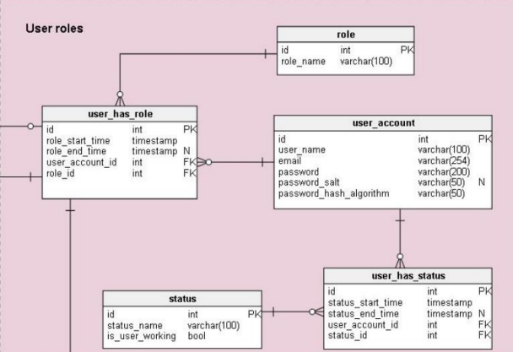

1. Insert data into each of the above tables. With at least two rows in each of the table, make sure, that you have created respective foreign keys.
2. Delete all the data from each of the tables.

-- Project 3

-- Problem Statement: How to convert a relational design into tables in SQL Server

-- Table 1 - User Role

CREATE TABLE role(

id INT PRIMARY KEY,

role_name VARCHAR(100)

);

-- Table 2 - user_has_role

CREATE TABLE user_has_role(

id INT PRIMARY KEY,

role_start_time DATETIME,

role_end_time DATETIME,

user_account_id INT FOREIGN KEY(user_account_id) REFERENCES user_has_role(id),

role_id INT FOREIGN KEY (role_id) REFERENCES user_has_role(id)

);

-- Table 3 - user account

CREATE TABLE user_account(

id INT PRIMARY KEY,

username VARCHAR(100),

email VARCHAR(254),

password VARCHAR(200),

password_salt VARCHAR(50),

password_hash_algorithm VARCHAR(50));

-- Table 4 - status

CREATE TABLE status(

id INT PRIMARY KEY,

status_name VARCHAR(100),

is_user_working BIT

);

-- Table 5 - user_has_status

CREATE TABLE user_has_status(

id INT PRIMARY KEY,

status_start_time DATETIME,

status_end_time DATETIME,

user_account_id INT FOREIGN KEY(user_account_id) REFERENCES user_has_role(id),

status_id INT FOREIGN KEY (status_id) REFERENCES user_has_role(id)

);

/* 1. Insert data into each of the above tables. With at least two rows in each of the table, make sure, that you have created respective foreign keys. */

-- Insert data into 'role' table

INSERT INTO role (id, role_name) VALUES

(1, 'Admin'),

(2, 'User');

select * from role;

-- Insert data into 'user_has_role' table

INSERT INTO user_has_role (id, role_start_time, role_end_time, user_account_id, role_id) VALUES

(1, '2023-01-01 00:00:00', '2023-01-31 23:59:59', 1, 1),

(2, '2023-02-01 00:00:00', '2023-02-28 23:59:59', 2, 2);

select * from user_has_role;

-- Insert data into 'user_account' table

INSERT INTO user_account (id, username, email, password, password_salt, password_hash_algorithm) VALUES

(1, 'admin_user', 'admin@example.com', 'admin_password_hash', 'admin_salt', 'SHA256'),

(2, 'regular_user', 'user@example.com', 'user_password_hash', 'user_salt', 'SHA256');

select * from user_account;

-- Insert data into 'status' table

INSERT INTO status (id, status_name, is_user_working) VALUES

(1, 'Active', 1),

(2, 'Inactive', 0);

select * from status;

-- Insert data into 'user_has_status' table

INSERT INTO user_has_status (id, status_start_time, status_end_time, user_account_id, status_id) VALUES

(1, '2023-01-01 00:00:00', '2023-01-31 23:59:59', 1, 1),

(2, '2023-02-01 00:00:00', '2023-02-28 23:59:59', 2, 2);

select * from user_has_status;

-- 2. Delete all the data from each of the tables.

-- Delete all data from 'role' table

DELETE FROM role;

-- Delete all data from 'user_has_role' table

DELETE FROM user_has_role;

-- Delete all data from 'user_account' table

DELETE FROM user_account;

-- Delete all data from 'status' table

DELETE FROM status;

-- Delete all data from 'user_has_status' table

DELETE FROM user_has_status;

-- Truncate all tables

TRUNCATE TABLE role;

TRUNCATE TABLE user_has_role;

TRUNCATE TABLE user_account;

TRUNCATE TABLE status;

TRUNCATE TABLE user_has_status;